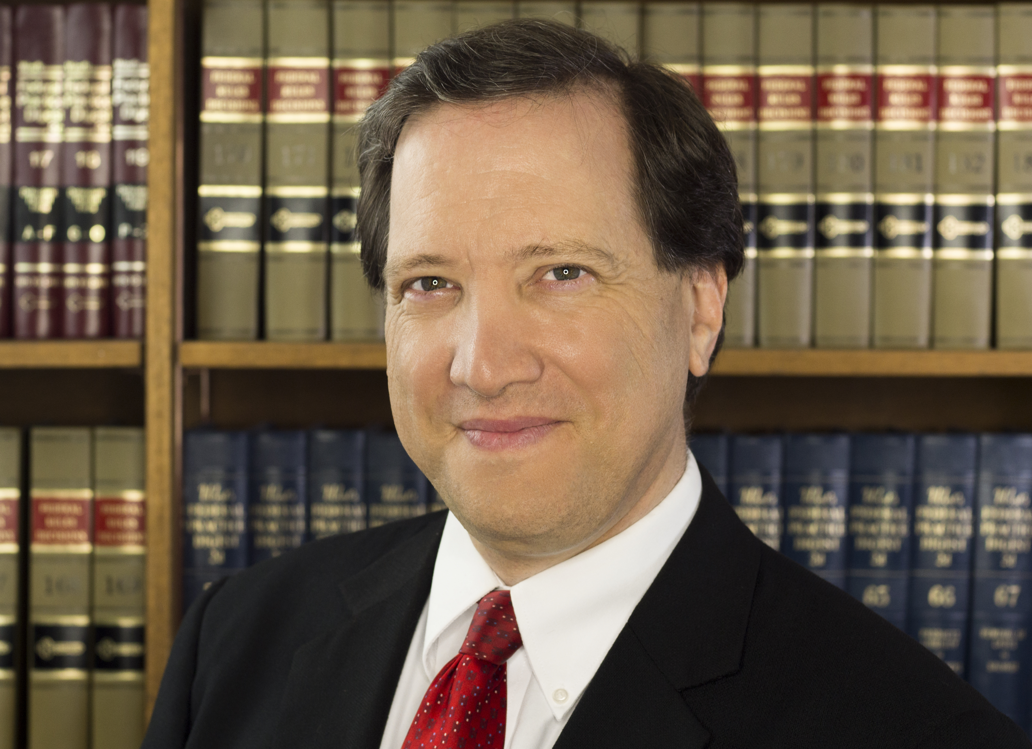

Scott Spallina

Senior Deputy Prosecuting Attorney
Supervisor – Elder Abuse Justice Unit
Office of the Prosecuting Attorney

Scott Spallina is the Senior Deputy Prosecuting Attorney in the Felony Review Division at the Honolulu Prosecutor’s Office, and has been with the office since 1995. During his 27 years with the office, Scott was the supervisor in charge of the Domestic Violence/Child Abuse Unit, and in 2008, established the Elder Abuse Justice Unit with the goal of “enhancing awareness, prevention, and prosecution of crimes affecting the elderly”. At that time, this was the first and only law enforcement unit in the State of Hawaii dedicated to prosecuting crimes where the victims were 60 years of age or older.

Scott has done over 70 jury trials, including handling over a dozen murder cases. In addition to his work on the courtroom, Scott has lectured in Hawaii and the mainland on subjects ranging from domestic violence and elder abuse, to care home liability, forensic investigation techniques, trial preparation and jury selection. He has also given over 400 presentations and trainings to various community groups, senior centers, and schools of nursing, and banks. He also lectures at the Honolulu Police Academy and U.H. Law School.

Before attending law school, Scott worked as a private investigator for Goodenow Associates/Safeguard Services in Honolulu where he focused on white collar crimes and missing persons. After graduation from the William S. Richardson School of Law at the University of Hawaii, he worked for the Attorney General’s Office in the Medicaid Fraud/Patient Abuse Division, as well as the law firm of Koshiba and Associates.

Contact Information
Office of the Prosecuting Attorney
1060 Richards Street
Honolulu, Hawaii 96813
(808) 768-6452
sspallina@honolulu.gov

